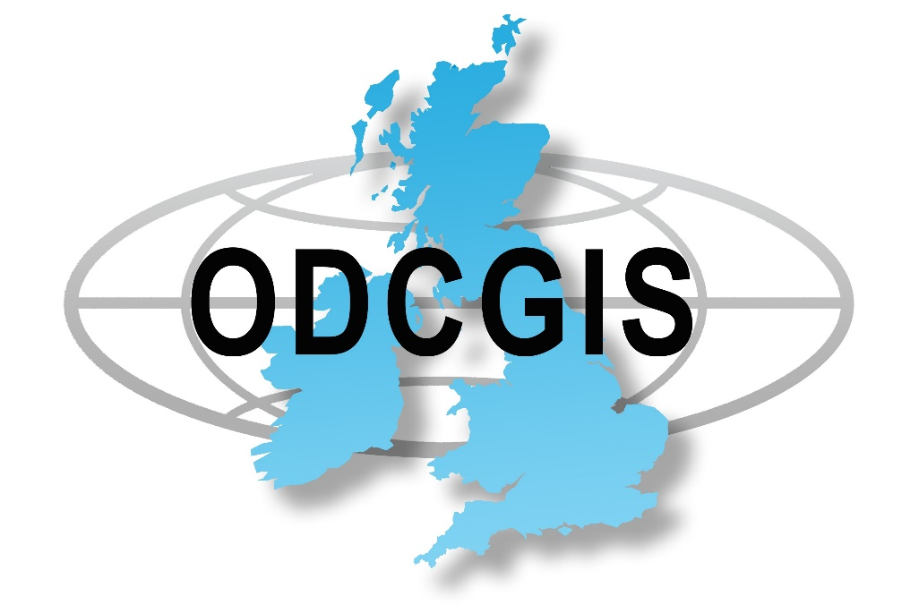

GDPR Website Privacy & Cookie Policy

Published by Craig Godwin,
Managing Director

Version 1.0

Issue Date November 2021

GDPR WEBSITE PRIVACY & COOKIE POLICY

ODCGIS is committed to protecting and respecting your privacy and complies with the requirements of the General Data Protection Regulation 2018 as introduced by the European Union. Our Website Privacy & Cookie Policy is set out for you here and tells you about the practices we follow to look after your personal data. It sets out the basis on which any personal data we collect from you, or that you provide to us, will be processed by us. Please read the policy carefully to understand our views and practices regarding your personal data and how we will treat it.

Signed

Craig Godwin
Managing Director

November 2021

Contents

1. Introduction 4
2. Policy Statement 4
3. INFORMATION WE COLLECT FROM YOU 5
4. COOKIES 7
5. HOW WE STORE YOUR PERSONAL DATA 8
6. DATA BREACH RESPONSE AND NOTIFICATION PROCEDURE 9
7. YOUR RIGHTS 10

1. Introduction
The General Data Protection Regulation (GDPR) was introduced by the European Union (EU) on 25th May 2018 to protect the personal data of EU citizens. Its purpose is to protect the “rights and freedoms” of EU citizens and to ensure that personal data is not processed without their knowledge and, wherever possible, that it is processed with their consent.

What is privacy protection?
Privacy protection is essentially that area of the law that governs what may, and what may not, be done with personal information. Such personal information may be in electronic (stored on computer hard drive) or manual form (in a manual filing system).

The law
GDPR is mandatory and ODCGIS is therefore required under law to comply. This means that we must:
- Notify the Information Commissioner’s Office (ICO)
- Educate and train staff in the correct use of data
Consequences of breaching GDPR:
- Staff can be criminally liable if they knowingly or recklessly disclose personal data in breach of GDPR.
- A serious breach of data protection is also a disciplinary offence and will be dealt with under the Law Centre’s disciplinary procedures. If a member of staff accesses another employee’s personnel records without authority this constitutes a gross misconduct offence and could lead to summary dismissal.

2. Policy Statement

ODCGIS (“We”, “Us”) are committed to protecting and respecting your privacy. This Privacy Notice (together with any other documents referred to herein) sets out the basis on which the personal data collected from you, or that you provide to Us, will be processed by Us in connection with Our website. Please read the following carefully to understand Our views and practices regarding your personal data and how We will treat it.
For the purpose of the General Data Protection Regulation (“GDPR”) and the version of the GDPR retained in UK law (the “UK GDPR”) the Data Controller is Craig Godwin.

3. Information We collect from You
We may collect the following Data, which includes limited personal Data, from you:
- name;
- gender;
- contact Information such as email addresses and telephone numbers;
- demographic information such as organisation name, address and postcode;
- IP address (automatically collected);
- web browser type and version (automatically collected);
- operating system (automatically collected);
- a list of URLs starting with a referring site, your activity on this Website, and the site you exit to (automatically collected);

In each case, in accordance with this privacy policy.

How We collect data

We collect Data in the following ways:
- data is given to us by you; and
- data is collected automatically.

Data that is given to Us by you

ODCGIS Ltd will collect your Data in a number of ways, for example:
- when you contact us through the Website, by telephone, post, e-mail or through any other means;
- when you register with us and set up an account to receive our products/services;
- when you complete surveys that we use for research purposes (although you are not obliged to respond to them);
- when you enter a competition or promotion through a social media channel;
- when you make payments to us, through this Website or otherwise;
- when you elect to receive marketing communications from us;
- when you use our services;

In each case, in accordance with this privacy policy.

Data that is collected automatically

To the extent that you access the Website, we will collect your Data automatically, for example:
- we automatically collect some information about your visit to the Website. This information helps us to make improvements to Website content and navigation, and includes your IP address, the date, times and frequency with which you access the Website and the way you use and interact with its content.
- we will collect your Data automatically via cookies, in line with the cookie settings on your browser. For more information about cookies, and how we use them on the Website, see the section below, headed “Cookies”.

Our use of data

Any or all of the above Data may be required by us from time to time in order to provide you with the best possible service and experience when using our Website. Specifically, Data may be used by us for the following reasons:
- internal record keeping;
- improvement of our products / services;
- transmission by email of marketing materials that may be of interest to you;
- contact for market research purposes which may be done using email, telephone, fax or mail. Such information may be used to customise or update the Website;

In each case, in accordance with this privacy policy.

- We may use your Data for the above purposes if we deem it necessary to do so for our legitimate interests. If you are not satisfied with this, you have the right to object in certain circumstances (see the section headed “Your rights” below).
- For the delivery of direct marketing to you via e-mail, we’ll need your consent, whether via an opt-in or soft-opt-in:
- soft opt-in consent is a specific type of consent which applies when you have previously engaged with us (for example, you contact us to ask us for more details about a particular product/service, and we are marketing similar products/services). Under “soft opt-in” consent, we will take your consent as given unless you opt-out.
- for other types of e-marketing, we are required to obtain your explicit consent; that is, you need to take positive and affirmative action when consenting by, for example, checking a tick box that we’ll provide.
- if you are not satisfied about our approach to marketing, you have the right to withdraw consent at any time. To find out how to withdraw your consent, see the section headed “Your rights” below.
- When you register with us and set up an account to receive our services, the legal basis for this processing is the performance of a contract between you and us and/or taking steps, at your request, to enter into such a contract.
- We may use your Data to show you Oxford Data Consultancy Limited adverts and other content on other websites. If you do not want us to use your data to show you Oxford Data Consultancy Limited adverts and other content on other websites, please turn off the relevant cookies (please refer to the section headed “Cookies” below).

Who We share data with

We may share your Data with the following groups of people for the following reasons:
- any of our group companies or affiliates – to ensure the proper administration of your website and business;
- our employees;
In each case, in accordance with this privacy policy.

Links to other websites

This Website may, from time to time, provide links to other websites including social media. We have no control over such websites and are not responsible for the content of these websites. This privacy policy does not extend to your use of such websites. You are advised to read the privacy policy or statement of other websites prior to using them.

4.Cookies

- This Website may place and access certain Cookies on your computer. ODCGIS Ltd uses Cookies to improve your experience of using the Website and to improve our range of services. ODCGIS Ltd has carefully chosen these Cookies and has taken steps to ensure that your privacy is protected and respected at all times.
- All Cookies used by this Website are used in accordance with current UK and EU Cookie Law.
- Before the Website places Cookies on your computer, you will be presented with a message bar requesting your consent to set those Cookies. By giving your consent to the placing of Cookies, you are enabling ODCGIS Ltd to provide a better experience and service to you. You may, if you wish, deny consent to the placing of Cookies; however certain features of the Website may not function fully or as intended.
- This Website may place the following Cookies:
Type of Cookie | Purpose
Analytical / performance cookies | They allow us to recognise and count the number of visitors and to see how visitors move around our website when they are using it. This helps us to improve the way our website works, for example, by ensuring that users are finding what they are looking for easily.
Functionality cookies | These are used to recognise you when you return to our website. This enables us to personalise our content for you, greet you by name and remember your preferences (for example, your choice of language or region
Targeting cookies | These cookies record your visit to our website, the pages you have visited and the links you have followed.

- You can find a list of Cookies that we use in the Cookie Schedule below.
- You can choose to enable or disable Cookies in your internet browser. By default, most internet browsers accept Cookies but this can be changed. For further details, please consult the help menu in your internet browser.
- You can choose to delete Cookies at any time; however you may lose any information that enables you to access the Website more quickly and efficiently including, but not limited to, personalisation settings.
- It is recommended that you ensure that your internet browser is up-to-date and that you consult the help and guidance provided by the developer of your internet browser if you are unsure about adjusting your privacy settings.
- For more information generally on cookies, including how to disable them, please refer to aboutcookies.org. You will also find details on how to delete cookies from your computer.

Cookie Schedule
Below is a list of the cookies that we use. We have tried to ensure this is complete and up to date, but if you think that we have missed a cookie or there is any discrepancy, please let us know.
Description of Cookie | Purpose
Google Analytics | We use this cookie to help us analyse how users use the website.
Wordpress | Website security plug-in
_utma | Keeps track of the number of times a visitor has been to the site pertaining to the cookie, when their first visit was, and when their last visit occurred.

5. How We store your Personal Data
Security
We take appropriate measures to ensure that all personal data is kept secure including security measures to prevent personal data from being accidentally lost, or used or accessed in an unauthorised way. We limit access to your personal data to those who have a genuine business need to know it. Those processing your information will do so only in an authorised manner and are subject to a duty of confidentiality.
We also have procedures in place to deal with any suspected data security breach. We will notify you and any applicable regulator of a suspected data security breach where We are legally required to do so.
Unfortunately, the transmission of information via the internet is not completely secure. Although We will do Our best to protect your personal data, We cannot guarantee the security of your data transmitted through any online means, therefore any transmission remains at your own risk.
Where We store your Personal Data
Data collected from website communications is stored within our CRM system (Really simple systems). And data collected as part of a GIS Project is stored within our AWS server based in London.

Data Retention
- Unless a longer retention period is required or permitted by law, we will only hold your Data on our systems for the period necessary to fulfil the purposes outlined in this privacy policy or until you request that the Data be deleted.
- Even if we delete your Data, it may persist on backup or archival media for legal, tax or regulatory purposes.

6. Data Breach Response and Notification Procedure

Data Breach is defined by The ICO (Information Commissioner’s Office) as any event that results in “the accidental or unlawful destruction, loss, alteration, unauthorised disclosure of, or access to, personal data”.
This includes incidents that involve:
- Unauthorised access from a third party;
- Deliberate or accidental action (or inaction) by a data controller or data processor;
- Sending personal data to an unintended recipient;
- Lost or stolen computing devices containing personal data;
- Unauthorised alteration of personal data; and
- Loss of availability of personal data.

In the event of a Data Breach Our Data Controller will be notified who in turn will notify the supervisory authority and yourselves immediately.

We maintain an internal record of all personal data breaches in a Data Breach Register which contains details of the facts surrounding the breach, the effects of the breach, and any remedial action taken.

7. Your rights
Under the General Data Protection Regulation and the UK GDPR, you have a number of important rights free of charge. In summary, those include rights to:
- access to your personal data and to certain other supplementary information that this Privacy Notice is already designed to address
- require Us to correct any mistakes in your information which We hold
- require the erasure of personal data concerning you in certain situations
- receive the personal data concerning you which you have provided to Us, in a structured, commonly used and machine-readable format and have the right to transmit those data to a third party in certain situations
- object at any time to processing of personal data concerning you for direct marketing
- object to decisions being taken by automated means which produce legal effects concerning you or similarly significantly affect you
- object in certain other situations to our continued processing of your personal data
- otherwise restrict our processing of your personal data in certain circumstances
- claim compensation for damages caused by our breach of any data protection laws.
For further information on each of those rights, including the circumstances in which they apply, see the Guidance from the UK Information Commissioner’s Office (ICO) on individuals rights under the UK GDPR.
If you would like to exercise any of those rights, please:
- contact us using our Contact details below
- let Us have enough information to identify you,
- let Us have proof of your identity and address, and
- let Us know the information to which your request relates.

How to complain
We hope that We can resolve any query or concern you raise about Our use of your information.
The General Data Protection Regulation and the UK GDPR also gives you right to lodge a complaint with a supervisory authority, in particular (under the GDPR) in the European Union (or European Economic Area) state where you work, normally live or where any alleged infringement of data protection laws occurred. The supervisory authority in the UK is the Information Commissioner who may be contacted at https://ico.org.uk/make-a-complaint or telephone: 0303 123 1113.

All questions, comments and requests regarding this Website Privacy Notice should be addressed to craig@odc.co.uk

